YR Autumn 1 Healthy Me
Things to talk about at home

- Who is in your family?
- What are your favourite meals?
- What are your favourite fruits and
vegetables?
- What different ways can we keep fit?
- How important it is to brush your teeth morning and evening.
- How important it is to wash our hands after using the toilet and before eating.
- Bedtime routines to include: washing and a bedtime story.

Key vocabulary
Family | 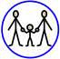 | People who are special to me like parents, brothers, sisters, grandparents, aunts, uncles and cousins
Fruit | 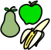 | The part of a plant that you can eat which contains the seeds
Vegetable | 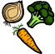 | The part of a plant that is used for food
Healthy |  | To feel well and have energy
Germs | 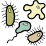 | Tiny living things that we can’t see which can make us sick
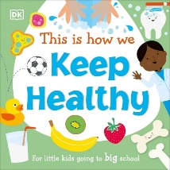
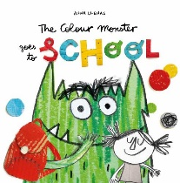
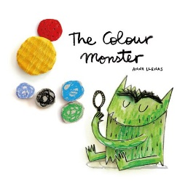
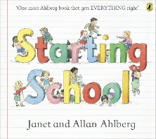
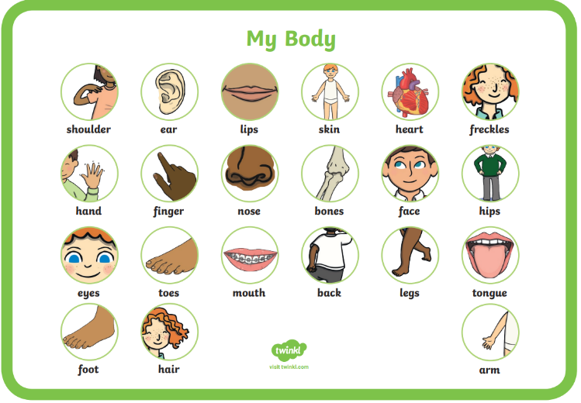
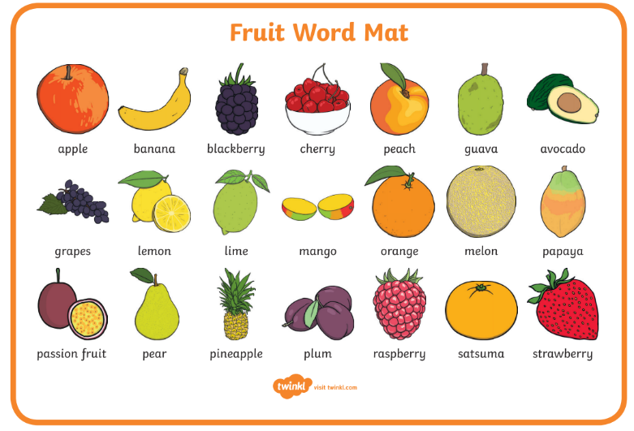
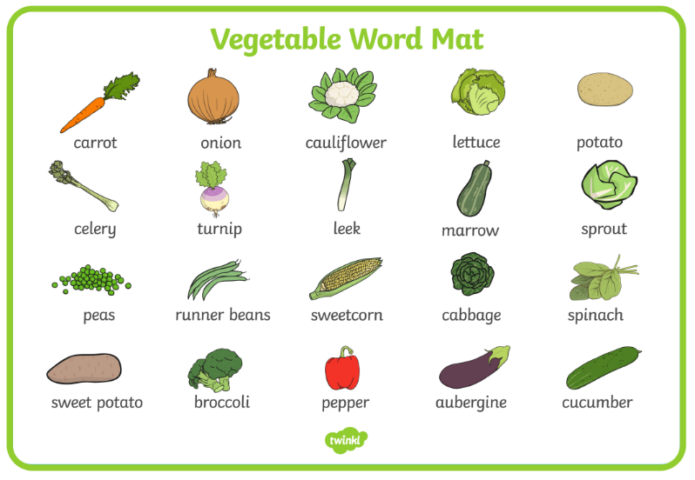
Useful Words
Key knowledge:
- Name the people in my family
- Know where I live, e.g. Popley, Basingstoke
- Name parts of the body, e.g. head, neck, arm, fingers, back
- Know the names of common fruits and vegetables
- Know which foods are healthy and which foods are treats
- Know the ways to stay healthy – drink water, brush your teeth, wash daily, eat healthy food, get plenty of sleep and exercise regularly

